Build your own
mobile robot

Build instructions

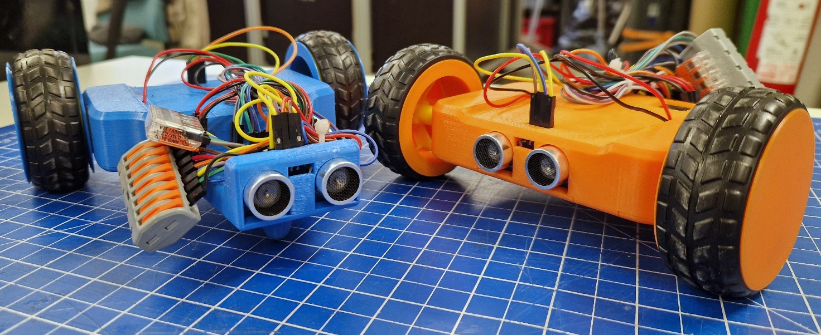
Contents
Introduction 3
Needed equipment 4
Information about the components 5
ESP8266 D1 mini 5
MP1584EN 5
L298N mini + 470 µF 5
HC-SR04 6
Motors 6
Lever connectors 6
AA batteries 6
Jumper cables 6
Build process 7
1. Uploading the code 7
2. Installing components to the hull 7
4. Wiring communication cables 8
5. First test 9
6. Wrapping up 10
Side notes 10
Wiring diagram 11

Introduction
Welcome to assemble your own mobile robot!
This build-it-yourself mobile robot is sure to impress, as it can be controlled using your own mobile device. It also features a simple collision avoidance system.
Once you have built the robot, you will understand the fundamentals of an embedded system comprising actuators and sensors—the same kind of interaction between actuators and sensors used in other robots.
This guide begins by listing the necessary components and providing some background information on them. Next, the assembly process is described in detail. Finally, you will find a simplified wiring diagram.
You can view a video of the assembly process via the accompanying QR code or link.
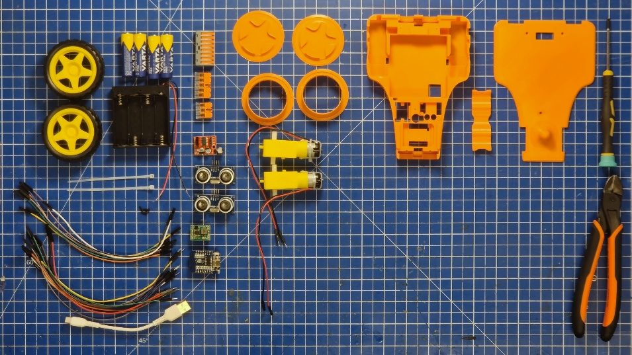

https://youtu.be/AeR3-ane96E

You can also access the robot's project page via the accompanying QR code or link; there, you will find all project-related files, including these instructions!

https://github.com/aapokek/Rakenna-oma-mobiilirobotti

Needed equipment
The table below lists the components and tools required to build the robot. The table is categorized into 3D-printable parts, components, and tools. You can find the files for the 3D-printable parts in the project folder (Rakenna-oma-mobiilirobotti/3D-mallit/). If you wish to print the parts yourself, use the STL or STEP files. Read more about the components and their uses in the next section!

Information about the components

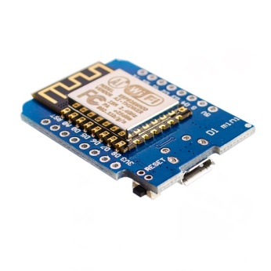
ESP8266 D1 mini
The ESP8266 D1 mini serves as the robot's brain. It is programmed to convert control signals from a smartphone into motor movement. Additionally, it reads distance data from HC-SR04 sensors and halts movement if an obstacle is detected nearby. The L298N mini motor driver and HC-SR04 sensors are connected to the labelled pins on the sides of the ESP8266 D1 mini.

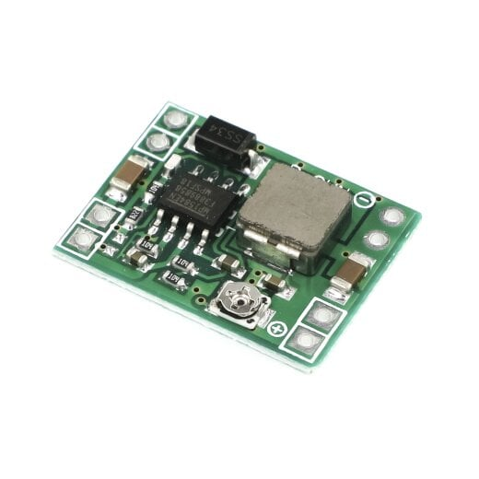
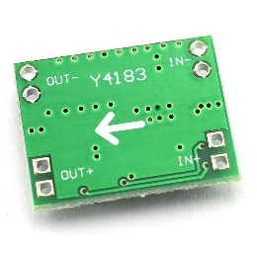
MP1584EN
The MP1584EN is a voltage converter that steps down and regulates the 6 V voltage from AA batteries to 3.3 V. This 3.3 V supply powers the ESP8266 D1 Mini and the HC-SR04 sensors. Please note the arrow on the back of the component indicating the direction of conversion. You can connect the power wire to either of the adjacent pins.

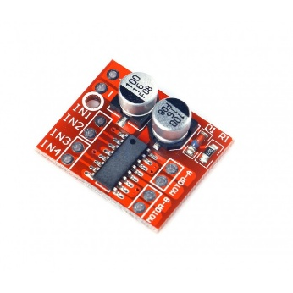
L298N mini + 470 µF
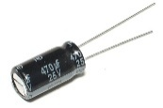
The L298N Mini controls the robot's motors based on signals sent by the ESP8266 D1 Mini. The L298N Mini has 10 connection pins. The component receives power directly from the battery via the +/- pins. The motors themselves connect to the MOTOR-A and MOTOR-B pins. Swapping the motor pin connections reverses the direction of rotation. Motor control is handled via pins IN1, IN2, IN3, and IN4, which are connected to the ESP8266 D1 Mini. Pins IN1 and IN2 control motor A, while IN3 and IN4 control motor B, as shown in the following table:
Motor state | IN1/IN3 | IN2/IN4
Forward | PWM | 0 V
Backwards | 0 V | PWM
Idle | 0 V | 0 V
Break | 3.3 V | 3.3 V
PWM (Pulse Width Modulation), as indicated in the table, is used to control the rotational speeds of the motors. A 470 µF capacitor has been soldered to the power pins of the L298N Mini to smooth out potential current spikes and improve motor performance.

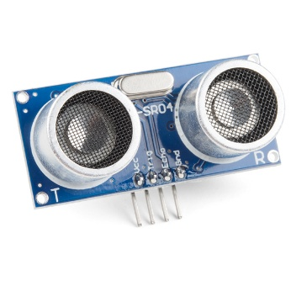
HC-SR04
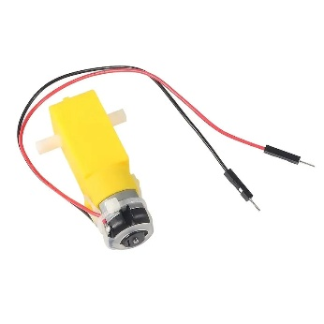
The HC-SR04 is a distance sensor that operates using ultrasonic pulses outside the range of human hearing. It functions based on the echo produced by an obstacle; the sensor emits short ultrasonic pulses and listens for their echoes. It can detect obstacles at up to 4 meters. The HC-SR04 has four pins: VCC, GND, Trig, and Echo. Power is supplied via the VCC and GND pins. The Trig pin is used to transmit the pulse. Upon detecting an echo, the sensor sends a signal to the Echo pin, which is registered by the ESP8266. In the robot, these sensors are used to prevent collisions during forward or backward movement. The ESP8266 D1 mini calculates the distance to the obstacle based on the time interval between pulse transmission and reception. In the implemented code, the robot is programmed to stop at 20–50 cm from the obstacle, depending on the set speed.

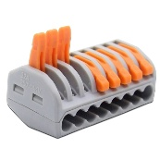
Motors
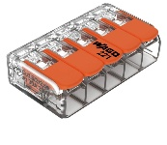
The robot is driven by small 1:48 geared motors. The yellow gearbox provides the robot with sufficient torque for movement. The motor itself is located at one end of the gearbox and is controlled by applying a voltage of 3–6 V to the power leads. Motor control is handled by an L298N Mini module, with the motor wires connected to its MOTOR-A or MOTOR-B pins. The direction of rotation can be reversed simply by swapping the wires.

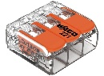
Lever connectors
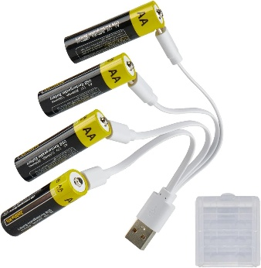
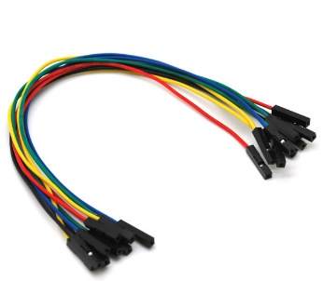
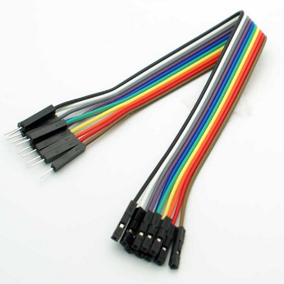
Lever connectors are easy-to-use cable connectors that allow two or more cables to be joined quickly without soldering. The operating principle of the lever connector is simple: first, the lever is opened; then, the cable is inserted into the connector; and finally, the lever is closed. The robot uses 3-, 5-, and 8-pole lever connectors to connect power cables. All ground wires (GND/-) are connected to the largest, 8-pole connector. The 6 V voltage from the batteries is distributed to the 3-pole connector, and the 3.3 V voltage to the 5-pole connector.

AA batteries
The robot is powered by four standard AA batteries. You can also use rechargeable AA batteries if you wish, but they must be 1.5 V lithium batteries (such as those shown in the image). Please note that standard rechargeable AA batteries often use NiMH chemistry and are therefore unsuitable due to their lower 1.2 V voltage.

Jumper cables
The components are connected to each other using jumper cables, which come in three types: 0-0, 0-1, and 1-1. Jumper cables allow for quick connections, as soldering is not required. The robot uses eight 0-0 jumper cables and twelve 0-1 jumper cables.

Build process
The robot assembly process consists of six stages, progressing from installing the code to attaching components and routing wires, followed by testing and finalization. You will find a wiring diagram on the last page of this guide to assist with the connections.

1. Uploading the code
The assembly process begins by installing the code onto the ESP8266 D1 Mini. Enter the robot's name and the password to be used on lines 2 and 3 of the code.
String robotName = "MunRobotti";
static const char* AP_PASSWORD = "OmaSalasana";
Later, you will connect to the Wi-Fi network using the name and password you specified. After making the edits, you can connect the ESP8266 D1 Mini to your computer via USB cable and click the blue arrow in the top-left corner of the Arduino IDE. The code has been successfully uploaded when you see the "Done uploading" notification. You can then disconnect the USB cable and proceed to the next step.

2. Installing components to the hull
Next, install all the electronic components onto the 3D-printed upper frame.
First, feed the motor wires through the holes on the side and gently press the motors into place. Ensure the wires straighten out and do not get pinched underneath the motor.
Press the following components into their designated slots:
- ESP8266 D1 mini
- MP1584EN
- L298N mini + 470 µF
- Both HC-SR04 sensors
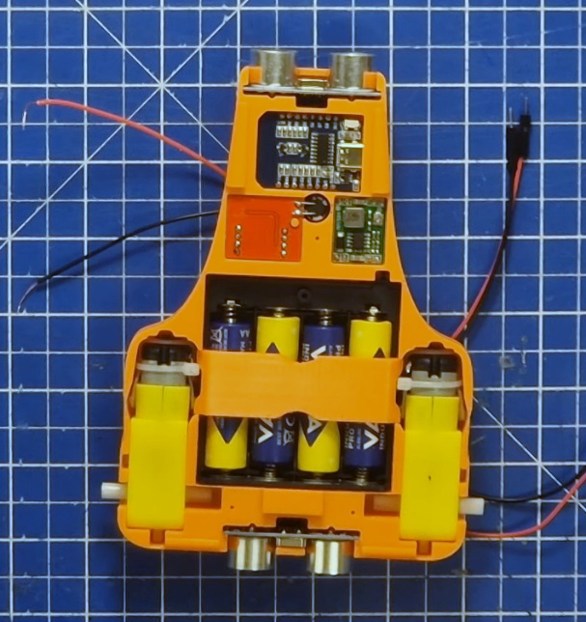
Next, take the battery holder and ensure its switch is in the OFF position to avoid the risk of a short circuit. Install the AA batteries. Route the battery wire through the small notch and slide the battery holder into place with the batteries facing upwards. Then, press the 3D-printed battery clip into position. The clip secures the batteries in the holder without needing the original battery cover. You can also use the cover that came with the holder, though replacing the batteries will be more difficult.
Great job! After the previous steps, your robot should look roughly like the one in the accompanying image!
Install the lower frame as the base of the robot. Leave the screws for the final assembly. Turn the robot over to connect the wires.
3. Wiring power cables
At this stage, we connect all the robot's power cables. This refers to all the red and black wires shown in the wiring diagram. The robot has a total of 18 power wires, 12 of which are connected using 0-1 jumper cables.
Begin connecting the power wires by attaching the motor power leads to the MOTOR-A and MOTOR-B pins on the L298N Mini. Reversing the motor wire connections will change the motor's direction of rotation; keep this in mind during the testing phase in case a motor spins the wrong way. The connection sequence shown in the wiring diagram has been verified to work correctly.
You can connect the remaining power wires in any order you prefer, but ensure you carry out the following steps.
Ground wire connections:
- Battery black wire (not a jumper cable) → 8-pole lever connector
- ESP8266 D1 mini G → 8-pole lever connector
- MP1584EN IN- → 8-pole lever connector
- MP1584EN OUT- → 8-pole lever connector
- L298N mini - → 8-pole lever connector
- Front HC-SR04 Gnd → 8-pole lever connector
- Rear HC-SR04 Gnd → 8-pole lever connector
6 V wiring:
- Battery red wire (not a jumper cable) → 3-pole lever connector
- MP1584EN IN+ → 3-pole lever connector
- L298N mini + → 3-pole lever connector
3.3 V wiring:
- MP1584EN OUT+ → 5-pole lever connector
- ESP8266 D1 mini 3V3 → 5-pole lever connector
- Front HC-SR04 Vcc → 5-pole lever connector
- Front HC-SR04 Vcc → 5-pole lever connector

4. Wiring communication cables
Now that all the components are powered up, it’s time to connect the communication wires!
The robot has a total of 8 communication wires, which are connected using 0-0 jumper wires. Please note that one end of each communication wire is already connected to the ESP8266 D1 Mini.
Make the following connections:
- L298N mini IN1 → ESP8266 D1
- L298N mini IN2 → ESP8266 D2
- L298N mini IN3 → ESP8266 D6
- L298N mini IN4 → ESP8266 D5
- Front HC-SR04 Trig → ESP8266 D7
- Front HC-SR04 Echo → ESP8266 D8
- Rear HC-SR04 Trig → ESP8266 D0
- Rear HC-SR04 Echo → ESP8266 D3

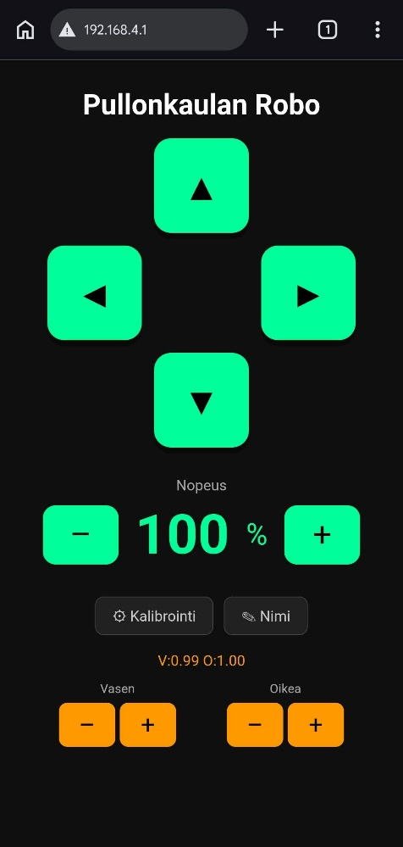
5. First test
Have the event supervisor check your wiring before you begin testing!
Your robot is now fully assembled and ready for its first test!
Install the 3D-printed wheel covers onto the wheels, attach the wheels, and turn on the power using the switch on the battery holder. The ESP8266 D1 mini will flash a blue light upon startup. Next, take out your smartphone and navigate to the Wi-Fi settings. Look for the network named after the robot and connect to it using the password you set. Once connected, your phone may automatically open the control interface. However, if nothing happens after connecting, open your phone's web browser and enter the IP address 192.168.4.1 into the address bar. The user interface shown in the accompanying image should then appear on your screen!
Verify the robot's operation by pressing the control buttons. If you notice that either or both motors are spinning in an unexpected direction, swap the power wire connections for the affected motor.

6. Wrapping up
Finish assembling the robot by screwing three mounting screws into its base. Finally, bundle the wires together using two cable ties. Note the two attachment points for the cable ties on the chassis. If you wish, you can calibrate your robot to move in a straight line via the calibration menu in the user interface, where you can reduce the motor speed on either side. You can also rename your robot using the naming menu. Please note that after renaming it, you will need to connect to the network using the new name and the original password you set.
Congratulations, your robot is now ready for use!
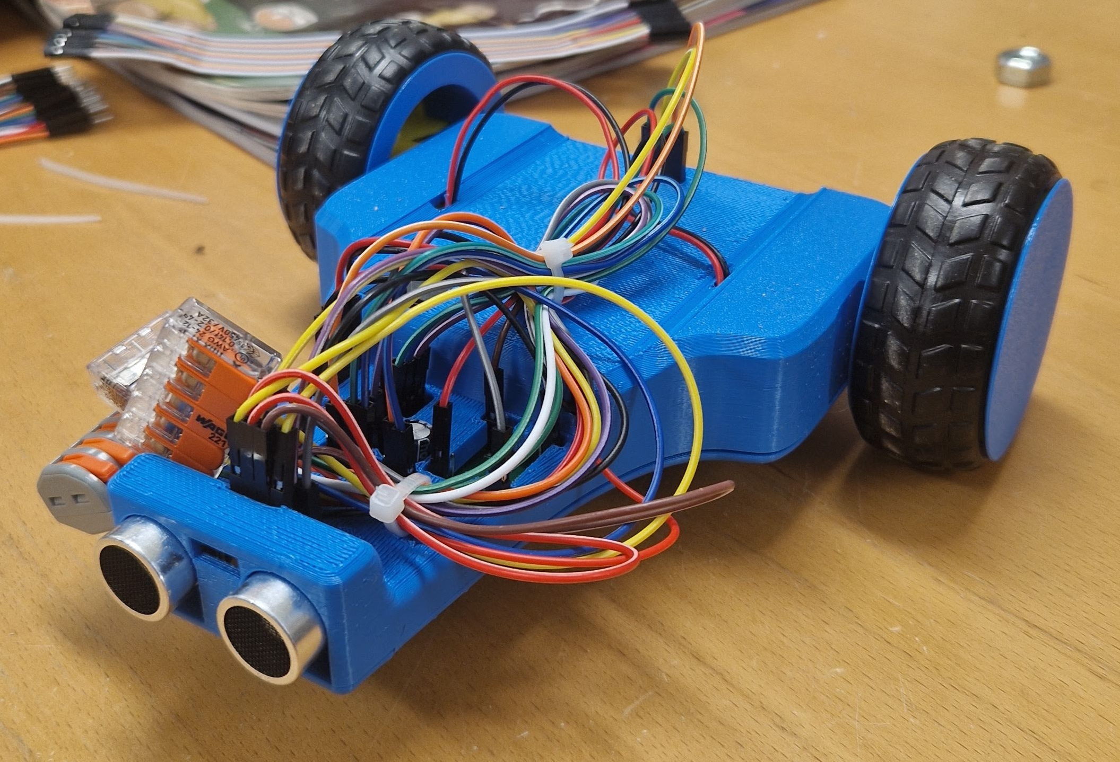

Side notes
The batteries last for several hours of active use, provided you remember to turn off the robot after use. You will notice the batteries running low if the connection is suddenly lost. If you plan to operate the robot frequently, we recommend purchasing rechargeable 1.5 V AA lithium batteries (not NiMH); these typically cost between €20 and €30 for a pack of four. They are often available with USB-C charging, eliminating the need for a separate charger.
You can also examine the robot's code, which is in the project folder (Rakenna-oma-mobiilirobotti/Koodit/Mobiilirobotin_koodi/Mobiilirobotin_koodi.ino).
You are free to modify the code as you wish (at your own risk) and update the robot's firmware accordingly. Remember to switch off the battery power before connecting the USB-C cable to the ESP8266. You can find further instructions on installing the code on your computer in the "Code installation" section on the project folder's main page.

Wiring diagram
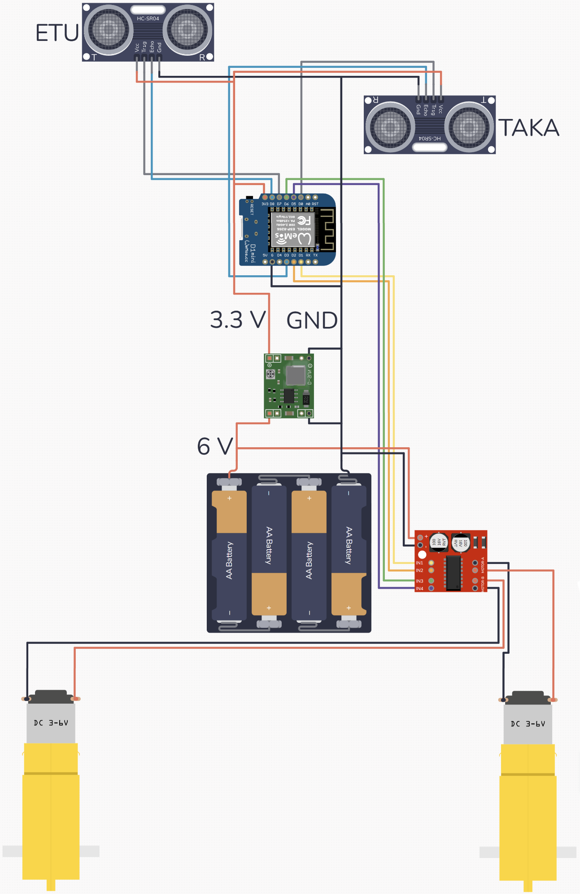
REAR
FRONT

